

Pisa University  
  
  
TASK 1  
LARGE-SCALE AND MULTI-STRUCTURED DATABASES

**“*PisaFlix” project documentation***  
academic year 2019-2020  
  
  
  
  
stefano petrocchi, Andrea Tubak, Francesco Ronchieri, Alessandro Madonna

Summary

Analysis Document 3

Description 3

Requirements 3

Main Actors 3

Functional 3

Non-Functional 4

Use Cases 4

Right detail 4

Left Detail 5

Analysis Classes 5

Data Model 5

Project Document 6

E-R Diagram 6

Application Architecture 7

Interface Design Pattern 7

Software Classes 8

Entities 8

DB-Manager 11

PisaFlix-Services 14

User Manual 18

Registration and login 19

Browsing Film/Cinemas 20

Film/Cinema Details 21

Browsing Users and Details 22

Projection 24

# Analysis Document

## Description

Have you ever found yourself in a gloomy day? Everyone is at home, no one knows what to do and time seems to slow down. That’s the perfect time for a **movie**! If you live within the *Pisan* suburb and you want to enjoy the best experience, ***PisaFlix*** is what you need.

*PisaFlix* is a platform in which you’ll find all of the information regarding **movies** and **cinemas** in the Pisa area. It gives you the possibility to know which cinema is available, which film you could watch and at what time all of the **projections** are due. PisaFlix has also a **comment** section both for cinemas and movies. This allows people to express their opinion, and, by doing so, providing others some really valuable information. Everyone who’s still unsure about what to do next will receive a great deal of help by this functionality. We believe *PisaFlix* offers a complete package of services, that will have a huge impact on the quality of the decisions made by our customers. Proving you everything you need to have a well-informed choice is not only our goal, but also a pleasure.

## Requirements

### Main Actors

The application will interact only with the **users**, distinguished by their privilege level:

* **Normal User**: a normal user of the application with the possibility of *basic inaction*.
* **Social Moderator**: a trusted user with the possibility to *moderate* the comments.
* **Moderator**: a verified user with the possibility to *add and modify elements* in the application, like films, cinemas or projections.
* **Admin:** an administrator of the application, with the possibility of a *complete interaction*.

### Functional

1. *Users* can **view** the list of **Movies/Cinemas** available on the platform.
2. *Users* can **view** the specific information about a *Movie* (es. category, publish date ecc…).
3. *Users* can **view** the specific information about a *Cinema* (es. Name, Address).
4. *Users* can **view** the *Projections* scheduled in a *Cinema*.
5. *Users* can **view** the *Projections* scheduled for a *Film*.
6. *Users* can **view** the list of ***favourites*** of other users (including himself).
7. *Users* can **register** an account on the platform.
8. *Users* can **log in** as *Normal users* on the platform in order to do some specific operations:
   1. If logged a *Normal user* can **add/remove** to **favourite** a *Movie/Cinema*.
   2. If logged a *Normal user* can **comment** a *Movie*/*Cinema*.
   3. If logged a *Normal user* can **modify** his *Movie*/*Cinema Comment*.
   4. A *Normal user* can **modify/delete** his account.
9. *Users* that can **log in** as *Social moderator* can do all operation of a *Normal user* plus:
   1. If logged as *Social moderator* can **delete** other users’ comments.
   2. If logged as *Social moderator* can **recruit** others *Social moderator*s.
10. *Users* that can **log in** as M*oderator* can do all operation of a *Social moderator* plus:
    1. If logged a *Moderator* can **add/delete/modify** a *Movie/Cinema/Projection*.
    2. If logged as *Moderator* can **recruit** other *Moderator*s
11. *Users* that can **log in** as*Admins* can do all operation of a M*oderator* plus:
    1. If logged an *Admin* can **delete** another user’s account.
    2. If logged as *Admin* can **recruit** other *Admin*s.

### Non-Functional

1. The systems must be on 24/24.
2. The system must support hundreds of concurrent access.
3. The response time must be in the order of 1-10 ms.
4. The password must be protected and stored encrypted for privacy issues.

## Use Cases

### Immagine che contiene elettronico Descrizione generata automaticamenteRight detail

### Left Detail

## Analysis Classes

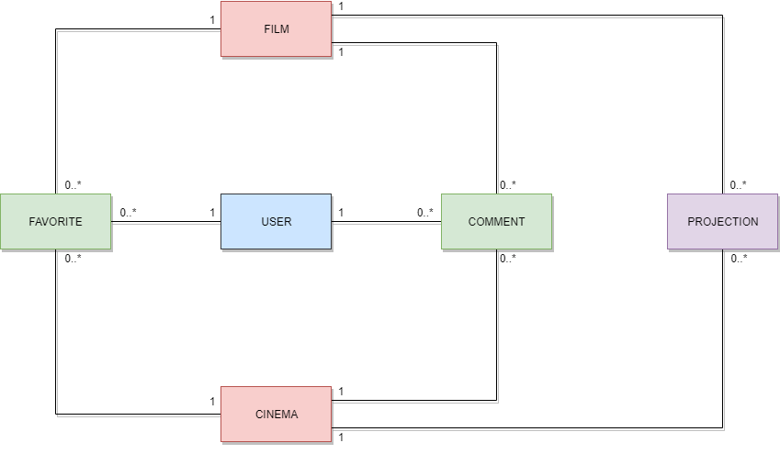

## Data Model

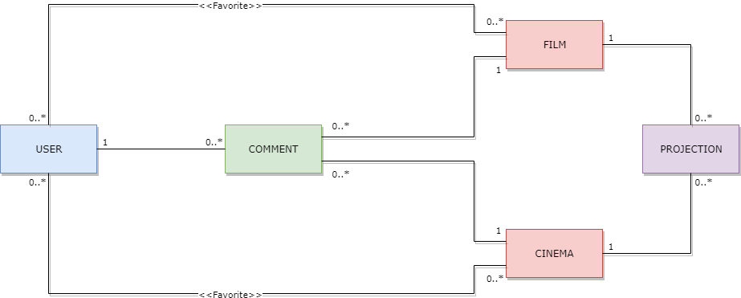

# Project Document

## E-R Diagram

The aim of this project is to build up the platform *PisaFlix*, a *MySQL* relational Database was chosen to store all the information about movies, cinemas, users etc.

The ***Database*** has the following schema:

**NOTE**: in the table *film_has_comment/cinema_has_comment* the field *idComment* must be UNIQUE, the tables were made in order to make Hibernate work properly.

## Application Architecture

Users can use a java application with a **GUI** to take advantage of all the functionalities of the platform.

The client Application is made in *Java* using **JavaFX framework** for the *front-end* and the **MongoDB driver** to manage *back-end* functionalities. **Services** and ***JavaBean* objects** compose the *middleware* infrastructure that connect *front-end* and *back-end.*

### Interface Design Pattern

The graphic user interface was build following the software design pattern of **Model-View-Controller**.

#### Model

**Services** module represents the *model* and it’s the central component of the pattern. It is the application's dynamic data structure, independent of the user interface. It directly manages logic and rules of the application receiving inputs from the controller. The model is also responsible for managing the application’s data in form of JavaBean objects, exchanging them with the controller.

#### View

The **fxml files** represents the *view* and are responsible for all the components visible in the user’s interface.

#### Controller

The **page controllers** are the *controller* of the application. They receive inputs from the *view* and convert them into commands for the *model* or *view* itself. Controllers can also validate inputs and data without the intervention of the *model*. Data is exchanged between *model* and *controller* using JavaBean objects.

## Software Classes

### ENTITIES

Diagram of the **classes**:

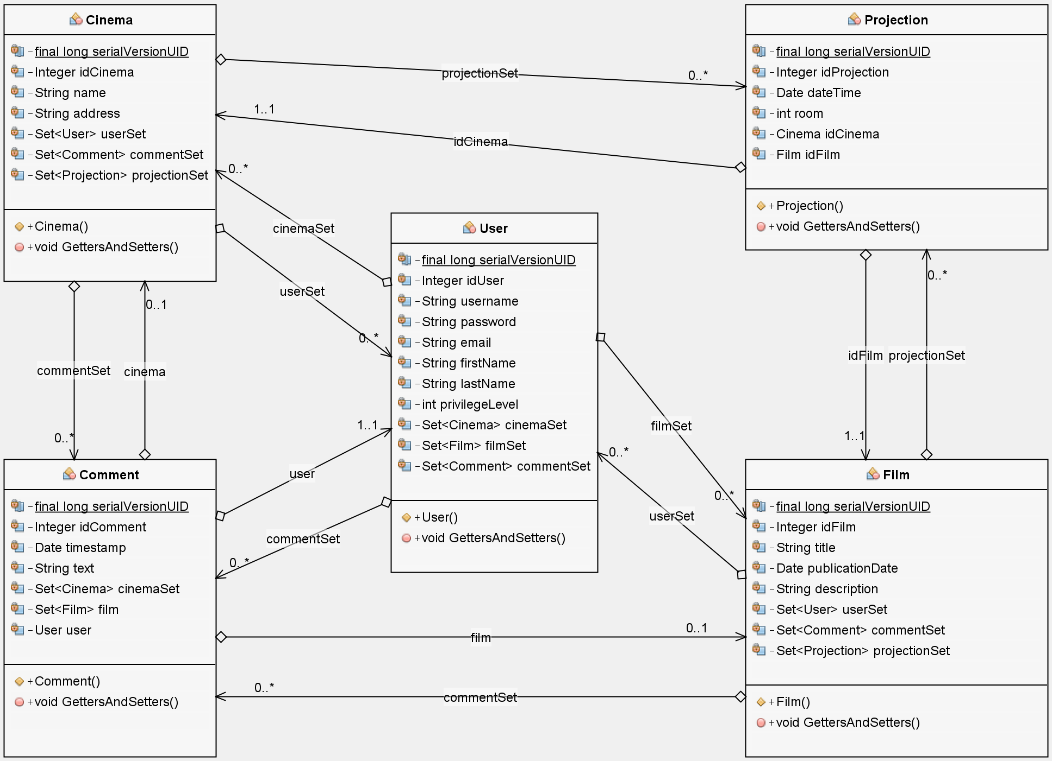

#### User

This entity class represents any **user**, in addition to the **personal information** necessary for their display on the application, the user's **privilege level** is present to allow him to perform only the actions allowed by it.

In ***cinemaSet*** the set of user favourite cinemas is saved, it allows to map the *many-to-many* relationship between entities *Cinema* and *User*, the same for ***filmSet***.   
***commentSet*** allows to map the *many-to-one* relationship between entities *Cinema* and *User.*

The getters and the class constructor are the only functions present.

#### Comment

This entity class represents any **comment**, the comment *text*, *id* and *creation date* are saved inside it.

The sets ***cinema*** and ***film*** contain the class of the entity to which the comment refers, only *one* of the two sets contains a *single* entity at a time, it is necessary to use sets and map the relationship between comments and cinema or films as *many-to-many*, instead of *many-to-one*, due to the particular type of association that exists between the *comment* table, the *has_comment* support tables and the *film* and *cinema* tables. This allows to normalize the relationship as much as possible and to avoid that an unused field always exists within the comment table.

The getters and the class constructor are the only functions present.

#### Projection

This entity class represents a **projection** of a specific movie (***idFilm***) scheduled in a specific cinema (***idCinema***) and contains the information about it.

The getters and the class constructor are the only functions present.

#### Cinema

This entity class represents any **cinema** and its information.

The set ***userSet*** is used to map the relationship *many-to-many* with the users that have that cinema in their favourites. The sets ***commentSet*** and ***projectionSet*** are used to map the *many-to-one* relationship between the cinema and the comments referred to it and the projections scheduled on it.

The getters and the class constructor are the only functions present.

#### Film

This entity class represents any **film** and its information.

The set ***userSet*** is used to map the relationship *many-to-many* with the users that have that movie in their favourites. The sets ***commentSet*** and ***projectionSet*** are used to map the *many-to-one* relationship between the movie and the comments referred to it and the projections of it.

The getters and the class constructor are the only functions present.

#### Hibernate DIrectives

The main aspects inside the classes are the directives for *Hibernate*, needed to perform *queries* on the database. A complete explanation on how they work is provided in the tutorial, an example for the *Film* entity is also provided below:

With @Entity is announced to *Hibernate* our entity **film**, the name of database table @Table(name = "Film") is specified after that.

We map each class field with the equivalent on the *database*:

* the directive @Id, before **private** Integer idFilm, specify that the field it’s part of the *primary key.*
* @GeneratedValue(strategy = GenerationType.IDENTITY) tells us that if not set will be generate automatically and it will be unique.
* @Basic(optional = **false**) tells that that field can’t be null.
* @Column(name = "idFilm") map the field *idFilm* with respective field in the database table.

The other fields are used to map relationship with other entities, for instance **private** Set<User> userSet is used to store all users who have the film as favourite.

The directives @JoinTable and @JoinColumn explain how to make the join with the database table, with @OneToMany(fetch = FetchType.EAGER) we specify the type of relationship and setting fetch = FetchType.EAGER we tell to *Hibernate* to automatically retrieve all users that put the film into their favourite when the film is retrieved itself.

Below the complete code:

1. //file Film.java
2. @Entity
3. @Table(name = "Film")
4. **public** **class** Film **implements** Serializable {
6. **private** **static** **final** **long** serialVersionUID = 1L;
8. @Id
9. @GeneratedValue(strategy = GenerationType.IDENTITY)
10. @Basic(optional = **false**)
11. @Column(name = "idFilm")
12. **private** Integer idFilm;
14. @Basic(optional = **false**)
15. @Column(name = "title")
16. **private** String title;
18. @Basic(optional = **false**)
19. @Column(name = "publicationDate")
20. @Temporal(TemporalType.DATE)
21. **private** Date publicationDate;
23. @Lob
24. @Column(name = "description")
25. **private** String description;
27. @JoinTable(name = "Favorite_Film", joinColumns = {
28. @JoinColumn(name = "idFilm", referencedColumnName = "idFilm")}, inverseJoinColumns = {
29. @JoinColumn(name = "idUser", referencedColumnName = "idUser")})
30. @ManyToMany(fetch = FetchType.EAGER)
31. **private** Set<User> userSet = **new** LinkedHashSet<>();
33. @ManyToMany(mappedBy = "filmSet", fetch = FetchType.EAGER, cascade = CascadeType.ALL)
34. @OrderBy
35. **private** Set<Comment> commentSet = **new** LinkedHashSet<>();
37. @OneToMany(mappedBy = "idFilm", fetch = FetchType.EAGER, cascade = CascadeType.ALL)
38. **private** Set<Projection> projectionSet = **new** LinkedHashSet<>();
40. //GETTERS AND SETTERS
41. }

### DB-Manager

The structure of **DBManager**:

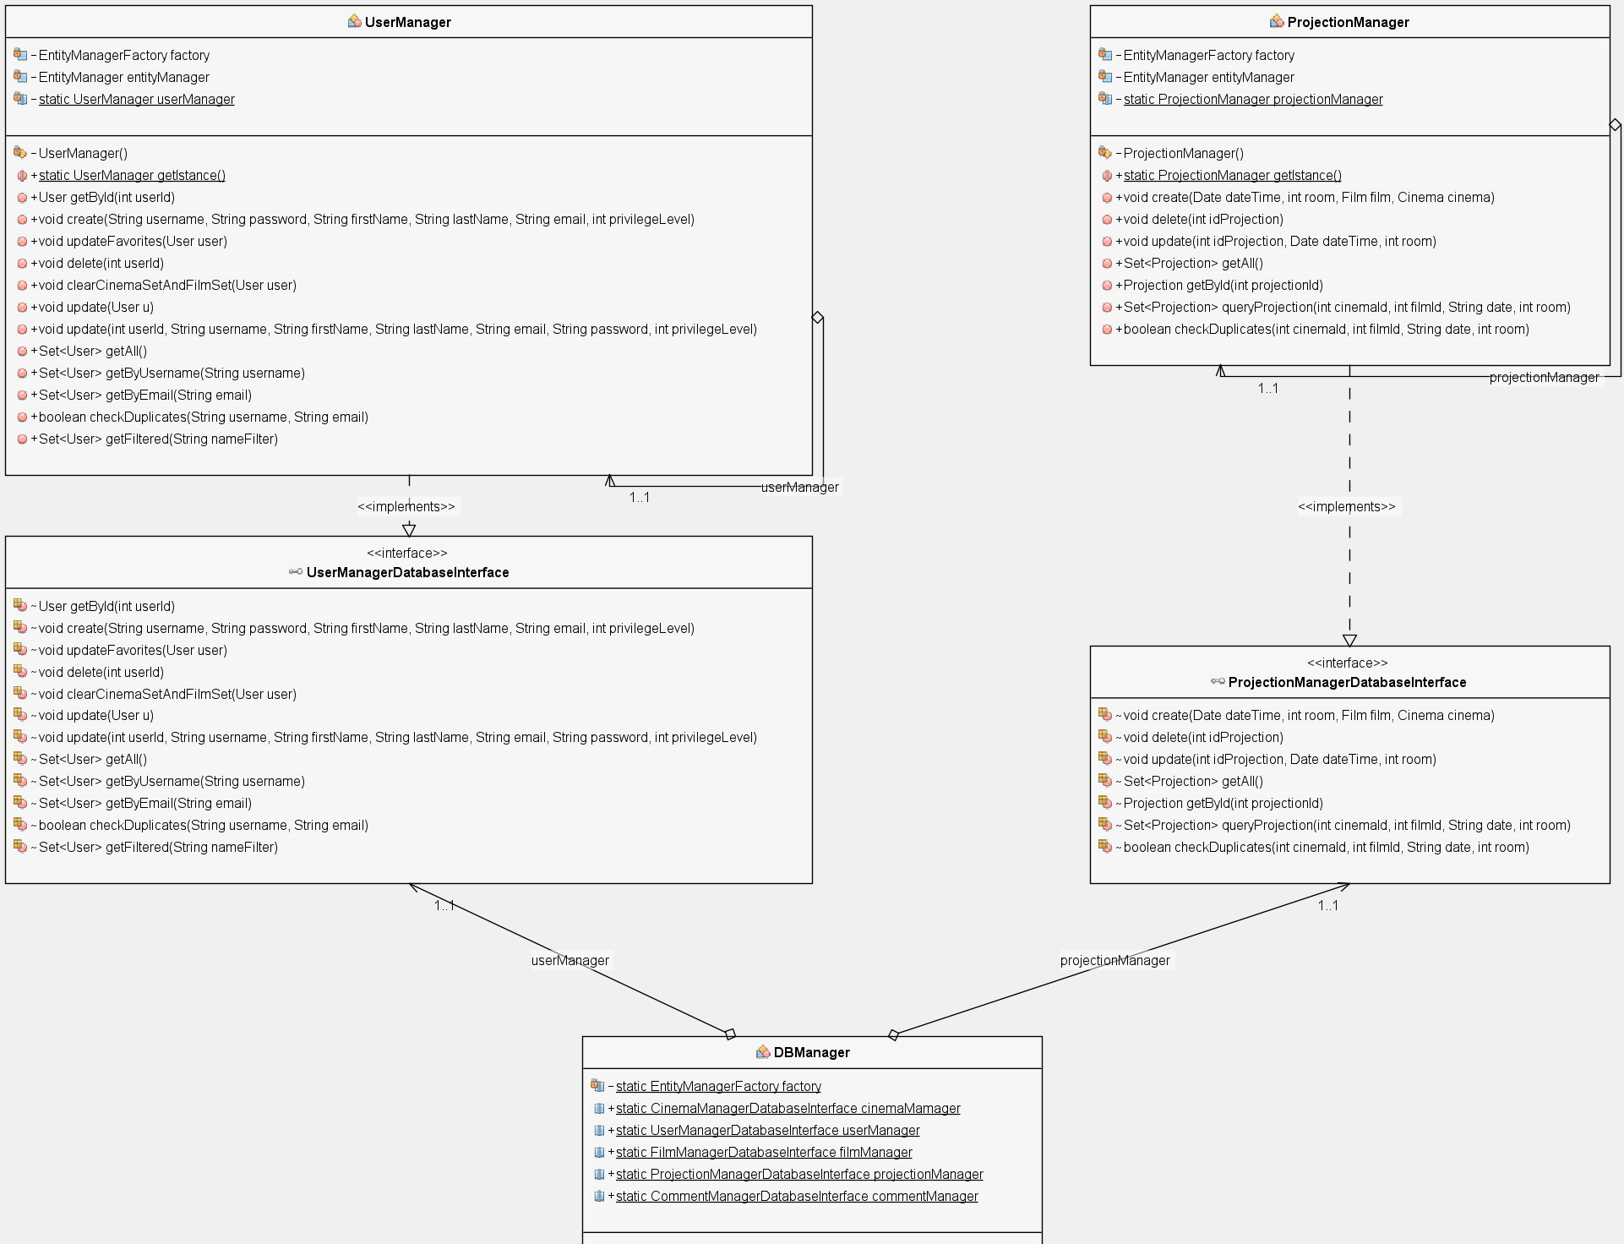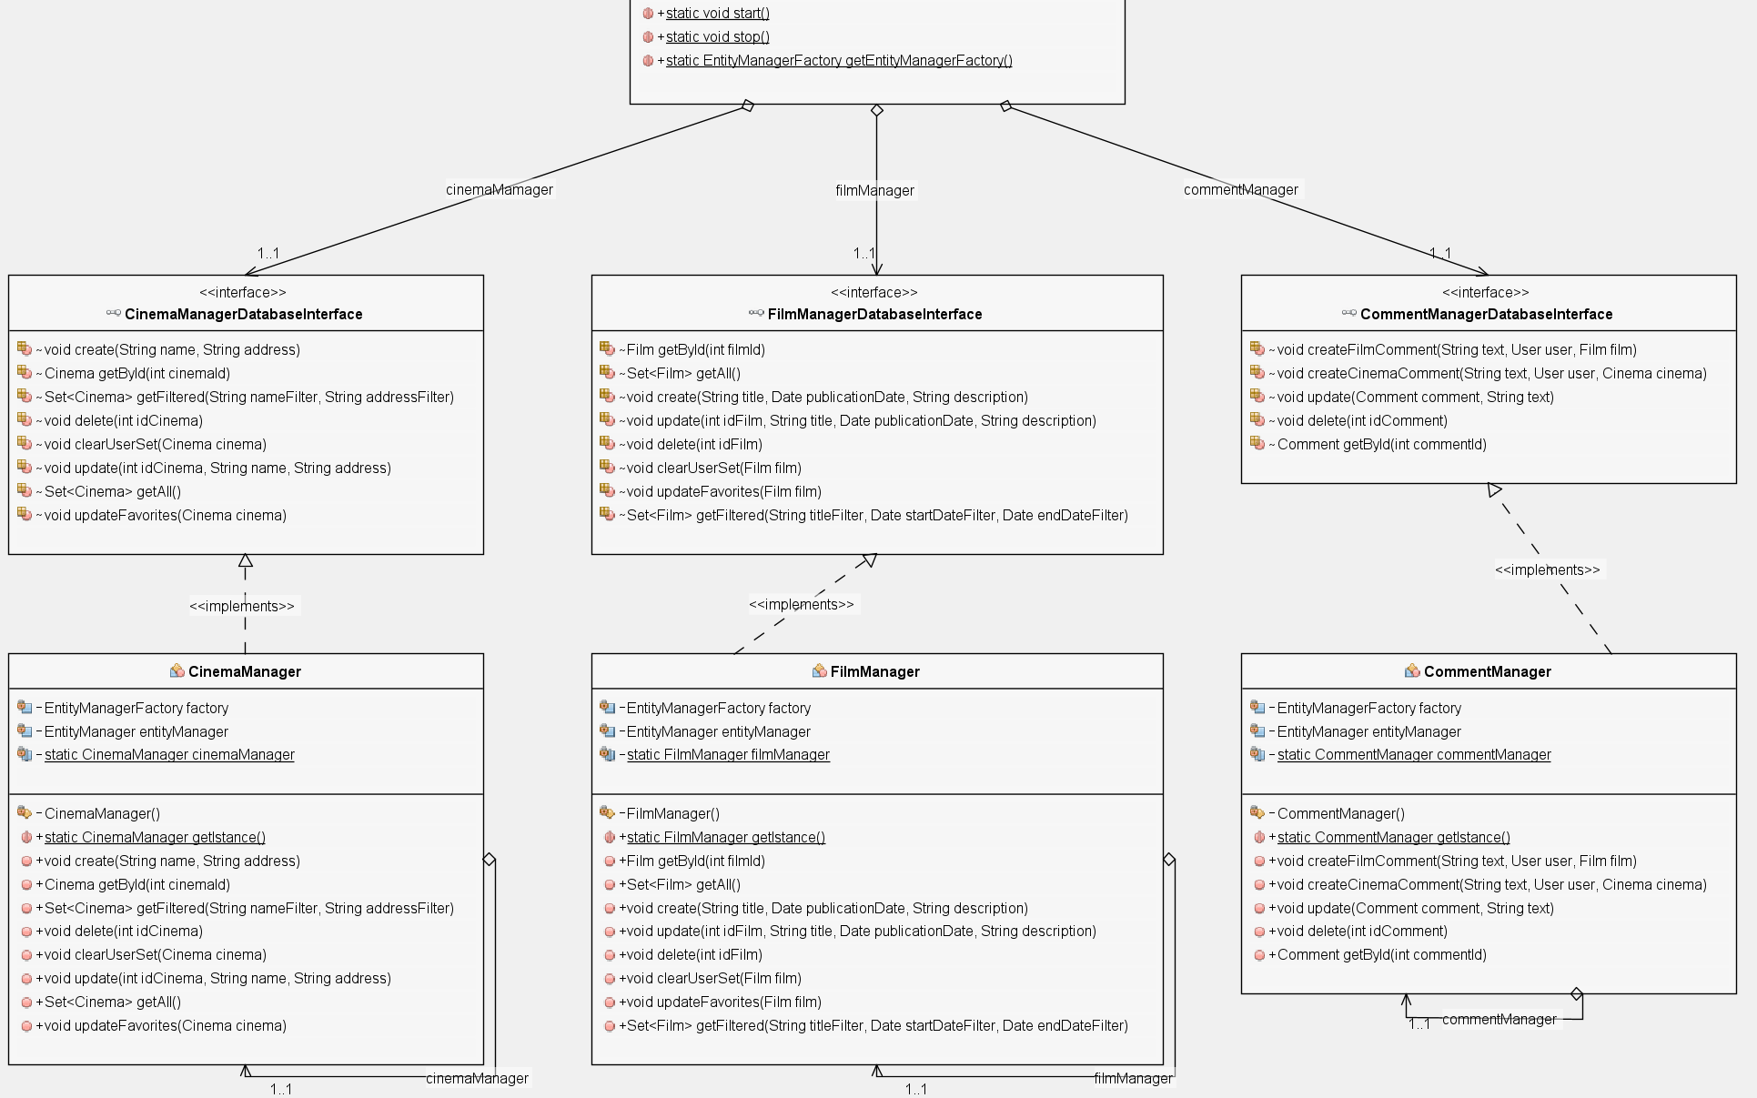

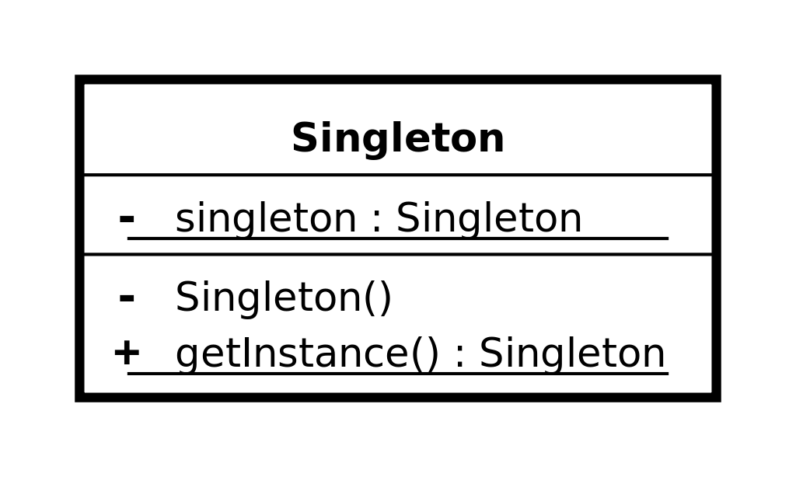All the managers are implemented following the software design pattern of ***singleton* pattern** which restricts the instantiation of a manager to one instance, Also the *EntityFactoryManager* used by *Hibernate* and managed in the *DBManager* class follows this design pattern.

The main classes and functions are described below:

* **DBManager** is an utility class, it’s a *static* class that contains all the other manager specific for certain operations, the other managers are accessible through the public members of the class, it automatically initialize all the managers on first call and the method *DBManager.Stop()* must be called at the end of the application in order to close the *factory manager* of *Hibernate*.
* **UserManagerDatabaseInterface** it’s the interface which defines the basic operation that any user manager should have (independent from the technology):
  + User **getById**(int *userId*);
  + void **create**(String *username*, String *password*, String *firstName*, String *lastName*, String *email*, int *privilegeLevel*);
  + void **updateFavorites**(User *user*);
  + void **delete**(int *userId*);
  + void **clearCinemaSetAndFilmSet**(User *user*);
  + void **update**(User *u*);
  + void **update**(int *userId*, String *username*, String *firstName*, String *lastName*, String *email*, String *password*, int *privilegeLevel*);
  + Set<User> **getAll**();
  + Set<User> **getByUsername**(String *username*);
  + Set<User> **getByEmail**(String *email*);
  + boolean **checkDuplicates**(String *username*, String *email*);
  + Set<User> **getFiltered**(String *nameFilter*);
* **UserManager** implements **UserManagerDatabaseInterface** and is in charge of manage all *CRUD* operation with the *database* for the user entities, all functions are self-explanatory by the name except for:
  + **getFiltered**(String *nameFilter*) which search and returns all users who have “*nameFilter*” in the username, if *nameFilter* is not set the filter it’s not taken into consideration and returns all users.
* **FilmManagerDatabaseInterface** it’s the interface which defines the basic operation that any film manager should have (independent from the technology):
  + Film **getById**(int *filmId*);
  + Set<Film> **getAll**();
  + void **create**(String *title*, Date *publicationDate*, String *description*);
  + void **update**(int *idFilm*, String *title*, Date *publicationDate*, String *description*);
  + void **delete**(int *idFilm*);
  + void **clearUserSet**(Film *film*);
  + void **updateFavorites**(Film *film*);
  + Set<Film> **getFiltered**(String *titleFilter*, Date *startDateFilter*, Date *endDateFilter*);
* **FilmManager** implements **FilmManagerDatabaseInterface** and is in charge of manage all *CRUD* operation with the database for the movie entities, all functions are self-explanatory by the name except for:
  + **getFiltered**(String *titleFilter*, Date *startDateFilter*, Date *endDateFilter*) which search and returns all movies which have “*titleFilter*” in the title and with *pubblicationDate* between “*startDateFilter”* and “*endDateFilter”*. If some filters are not set, are not taken into consideration by the function, if all filter are not set it returns all movies.
* **CinemaManagerDatabaseInterface** it’s the interface which defines the basic operation that any cinema manager should have (independent from the technology):
  + void **create**(String *name*, String *address*);
  + Cinema **getById**(int *cinemaId*);
  + Set<Cinema> **getFiltered**(String *nameFilter*, String *addressFilter*);
  + void **delete**(int *idCinema*);
  + void **clearUserSet**(Cinema *cinema*);
  + void **update**(int *idCinema*, String *name*, String *address*);
  + Set<Cinema> **getAll**();
  + void **updateFavorites**(Cinema *cinema*);
* **CinemaManager** implements **CinemaManagerDatabaseInterface** and is in charge of manage all *CRUD* operation with the database for the cinema entities, all functions are self-explanatory by the name except for:
  + **getFiltered**(String *nameFilter*, String *addressFilter*)which search and returns all cinemas which have “*nameFilter*” in the name and the “*addressFilter”* in the address. If some filters are not set, are not taken into consideration by the function, if all filter are not set it returns all movies.
* **ProjectionManagerDatabaseInterface** it’s the interface which defines the basic operation that any projection manager should have (independent from the technology):
  + void **create**(Date *dateTime*, int *room*, Film *film*, Cinema *cinema*);
  + void **delete**(int *idProjection*);
  + void **update**(int *idProjection*, Date *dateTime*, int *room*);
  + Set<Projection> **getAll**();
  + Projection **getById**(int *projectionId*);
  + Set<Projection> **queryProjection**(int *cinemaId*, int *filmId*, String *date*, int *room*);
  + boolean **checkDuplicates**(int *cinemaId*, int *filmId*, String *date*, int *room*);
* **ProjectionManager** implements **ProjectionManagerDatabaseInterface** and is in charge of manage all *CRUD* operation with the database for the projection entities, all functions are self-explanatory by the name except for:
  + **queryProjection**(int *cinemaId*, int *filmId*, *String* *date*, int *room*)which search and returns all projections for cinema specidied by “*cinemaId*” and the film specified by “*filmId”,* it also take in consideration the date specidied by “*date”* and the room specified by “*room”*. If some filters are not set, are not taken into consideration by the function, if all filter are not set it returns all movies.
* **CommentManagerDatabaseInterface** it’s the interface which defines the basic operation that any comment manager should have (independent from the technology):
  + void **createFilmComment**(String *text*, User *user*, Film *film*);
  + void **createCinemaComment**(String *text*, User *user*, Cinema *cinema*);
  + void **update**(Comment *comment*, String *text*);
  + void **delete**(int *idComment*);
  + Comment **getById**(int *commentId*);
* **CommentManager** implements **CommentManagerDatabaseInterface** and is in charge of manage all *CRUD* operation with the database for the comments, all functions are self-explanatory and therefore not described in detail.

### PISAFLIX-Services

Due to its complexity, a diagram of the services offered by the application is provided below: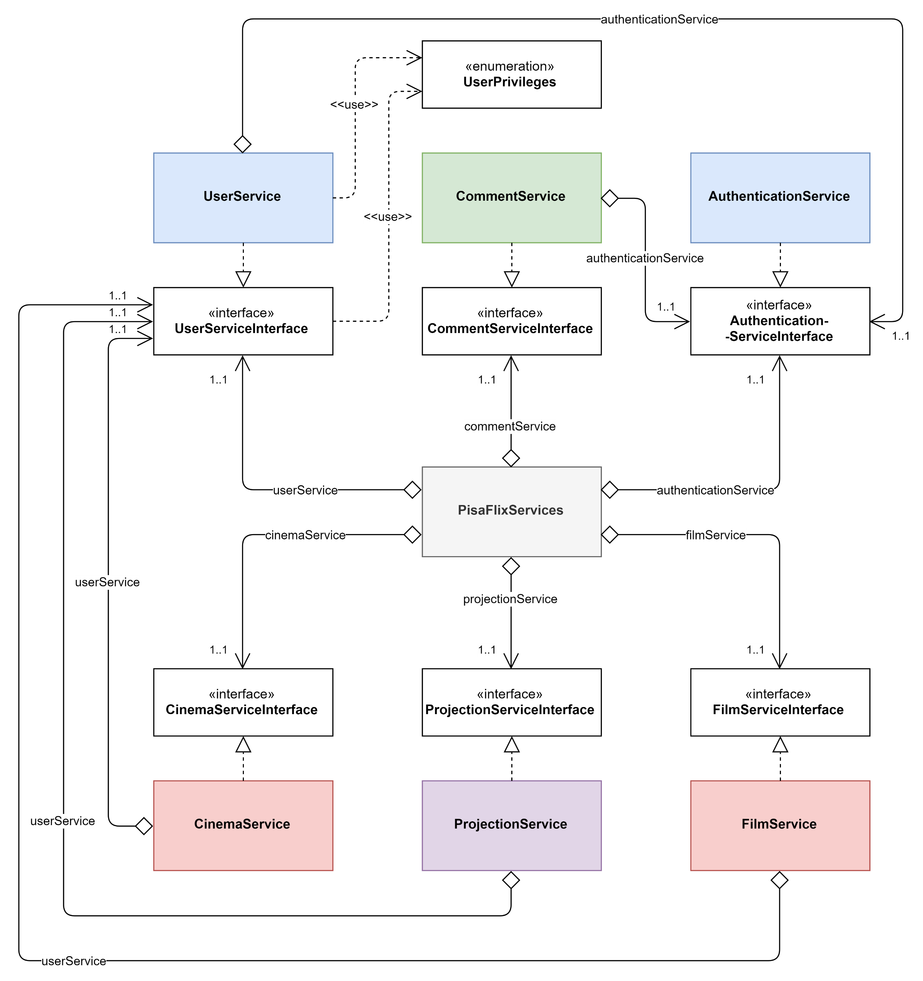

The **PisaFlixServices** follows the same structure of *DBManager*, all single services follow the *singleton* software design pattern explained before.

The main classes and functions are described below:

* **PisaFlixServices** is a utility class, it’s a static class that contains all the other service managers specific to certain operations, the other services are accessible through the public members of the class, it automatically initializes all the services on first call.
* **UserPrivileges** it’s an enumeration class which map the user privileges:
  + NORMAL_USER -> level 0 of DB
  + SOCIAL_MODERATOR -> level 1 of DB
  + MODERATOR -> level 2 of DB
  + ADMIN -> level 3 of DB
* **AuthenticationServiceInterface** it’s the interface which defines the basic operation that any authentication service should have (independent from the technology):
  + we will see the methods in detail in the class which implement it
* **AuthenticationService** implements **AuthenticationServiceInterface** and is in charge of manage the authentication procedure of the application, it uses **UserManagerDatabaseInterface** in order to operate with database and obtain data:
  + void **login**(String *username*, String *password*) if called with valid credentials it makes the log in and saves the users information in a local variable opening a kind of session, it may throw *UserAlredyLoggedException*if called with an already open session or *InvalidCredentialsException* if called with invalid credentials
  + void **logout**() it closes the session deleting user information stored in the local variable
  + boolean **isUserLogged**() it checks if the user is logged and give back the results
  + String **getInfoString**() it provides some text information of the current session (ex. “logged as Example”
  + User **getLoggedUser**() get the information of the loggedUser
* **UserServiceInterface** it’s the interface which defines the basic operation that any user service should have (independent from the technology):
  + we will see the methods in detail in the class which implement it
* **UserService** implements **UserServiceInterface** and is in charge of manage all operations that are specific for users, in order to work properly it use an **UserManagerDatabaseInterface** to exchange datawith the DB andan **AuthenticationServiceInterface** for ensure a correct session status depending by the operation that we want to perform:
  + Set<User> **getAll**() returns all the users in the DB
  + User **getUserById**(int *id*) returns a specific user identify by its “*id*”
  + Set<User> **getFiltered**(String *nameFilter*) search and returns all users who have “*nameFilter*” in the username, if *nameFilter* is not set the filter it’s not taken into consideration and returns all users.
  + void **updateUser**(User *user*) updates a user in the database with new information specify by its parameter
  + void **register**(String *username*, String *password*, String *email*, String *firstName*, String *lastName*) it registers a new user in the database, if some field It’s not valid it throws *InvalidFieldException* specify also the reason why it was thrown
  + void **checkUserPrivilegesForOperation**(UserPrivileges *privilegesToAchieve*, String *operation*) checks if the logged user has the right privileges in order to do an operation, it does do nothing if he has them, otherwise it throws *InvalidPrivilegeLevelException*, it may also throw *UserNotLoggedException* if called without an active session, the field operation it used just to print the operation that we would like to perform in the error message.
  + void **checkUserPrivilegesForOperation**(UserPrivileges *privilegesToAchieve*) it just calls **checkUserPrivilegesForOperation**(UserPrivileges *privilegesToAchieve*, String *operation*) with a default text for the “*operation"* field
  + void **changeUserPrivileges**(User *u*, UserPrivileges *newPrivilegeLevel*) allows the logged user to change the privileges of a user (it can also be itself) it throws *UserNotLoggedException* if called with no user logged, or *InvalidPrivilegeLevelException* if the logged user can’t change the privileges of the target user;
  + void **deleteUserAccount**(User *u*) allows the logged user to delete a user (it can also be itself) it throws *UserNotLoggedException* if called with no user logged, or *InvalidPrivilegeLevelException* if the logged user can’t delete the target user;
  + void **deleteLoggedAccount**() it just calls **deleteUserAccount**(User *u*) with the user logged as parameter.
* **FilmServiceInterface** it’s the interface which defines the basic operation that any film service should have (independent from the technology):
  + we will see the methods in detail in the class which implement it
* **FilmService** implements **FilmServiceInterface** and is in charge of manage all operations that are specific for films, in order to work properly it use an **FilmManagerDatabaseInterface** to exchange datawith the DB anda **UserServiceInterface** for ensure that we have the right privileges depending by the operation that we want perform:
  + Set<Film> **getFilmsFiltered**(String *titleFilter*, Date *startDateFilter*, Date *endDateFilter*) search in the DB and returns all movies which have “*titleFilter*” in the title and the *pubblicationDate* it’s between “*startDateFilter”* and “*endDateFilter*”, if some filter is not set the filter it’s not taken into consideration, if all filter are not set it returns all movies.
  + Set<Film> **getAll**() returns all movies int the DB
  + Film **getById**(int *id*) returns a specific film identify by its “*id*”
  + void **addFilm**(String *title*, Date *publicationDate*, String *description*) allows to insert a new film in the DB, it throws *UserNotLoggedException* if called with no user logged, or *InvalidPrivilegeLevelException* if the logged user can’t add a new film
  + void **updateFilm**(Film *film*) allows to modify a film in the DB, it throws *UserNotLoggedException* if called with no user logged, or *InvalidPrivilegeLevelException* if the logged user can’t modify a film
  + void **deleteFilm**(int *idFilm*) allows to delete a film in the DB, it throws *UserNotLoggedException* if called with no user logged, or *InvalidPrivilegeLevelException* if the logged user can’t delete a film
  + void **addFavorite**(Film *film*, User *user*) allows to add a specific “*film”* as favourite of a specific “*user”*
  + void **removeFavourite**(Film *film*, User *user*) allows to remove a specific “*film”* as favourite of a specific “*user”*
* **CinemaServiceInterface** it’s the interface which defines the basic operation that any cinema service should have (independent from the technology):
  + we will see the methods in detail in the class which implement it
* **CinemaService** implements **CinemaServiceInterface** and is in charge of manage all operations that are specific for cinemas, in order to work properly it use an **FilmManagerDatabaseInterface** to exchange datawith the DB andan **UserServiceInterface** for ensure that we have the right privileges depending by the operation that we want perform:
  + Set<Cinema> **getAll**() returns all cinemas int the DB
  + Set<Cinema> **getFiltered**(String *name*, String *address*) search int the DB and returns all cinemas which have “*nameFilter*” in the name and the “*addressFilter”* in the address, if some filter is not set the filter it’s not taken into consideration, if all filter are not set it returns all cinemas.
  + Cinema **getById**(int *id*) returns a specific film identify by his “*id”*
  + void **addCinema**(String *name*, String *address*) allows to insert a new cinema in the DB, it throws *UserNotLoggedException* if called with no user logged, or *InvalidPrivilegeLevelException* if the logged user can’t add a new cinema
  + void **updateCinema**(Cinema *cinema*) allows to modify a cinema in the DB, it throws *UserNotLoggedException* if called with no user logged, or *InvalidPrivilegeLevelException* if the logged user can’t modify a cinema
  + void **deleteCinema**(Cinema *cinema*) allows to delete a cinema in the DB, it throws *UserNotLoggedException* if called with no user logged, or *InvalidPrivilegeLevelException* if the logged user can’t delete a cinema
  + void **addFavorite**(Cinema *cinema*, User *user*) allows to add a specific “*film”* as favourite of a specific “*user”*
  + void **removeFavourite**(Cinema *cinema*, User *user*) allows to remove a specific “*film”* as favourite of a specific “*user”*
* **CommentServiceInterface** it’s the interface which defines the basic operation that any comment service should have (independent from the technology):
  + we will see the methods in detail in the class which implement it
* **CommentService** implements **CommentServiceInterface** and is in charge of manage all operations that are specific for comments, in order to work properly it use an **CommentManagerDatabaseInterface** to exchange datawith the DB, an **AuthenticationService** in order to retrieve the current logged user and an **UserServiceInterface** for ensure that we have the right privileges depending by the operation that we want perform:
  + Comment **getById**(int *id*) returns a specific film identify by its “*id”*
  + void **addFilmComment**(String *comment*, User *user*, Film *film*) creates a new comment for a “*film*” made by a certain “*user*”
  + void **addCinemaComment**(String *comment*, User user, Cinema *cinema*) creates a new comment for a “*cinema*” made by a certain “*user*”
  + void **update**(Comment *comment*) allows to modify a comment in the DB, it throws *UserNotLoggedException* if called with no user logged, or *InvalidPrivilegeLevelException* if the logged user can’t modify the comment
  + void **delete**(Comment *comment*) allows to delete a comment in the DB, it throws *UserNotLoggedException* if called with no user logged, or *InvalidPrivilegeLevelException* if the logged user can’t delete the comment
* **ProjectionServiceInterface** it’s the interface which defines the basic operation that any projection service should have (independent from the technology):
  + we will see the methods in detail in the class which implement it
* **ProjectionService** implements **ProjectionServiceInterface** and is in charge of manage all operations that are specific for projections, in order to work properly it use an **CommentManagerDatabaseInterface** to exchange datawith the DB and an **UserServiceInterface** for ensure that we have the right privileges depending by the operation that we want perform:
  + void **addProjection**(Cinema c, Film f, Date d, int room) allows to insert a new projection in the DB, it throws *UserNotLoggedException* if called with no user logged, or *InvalidPrivilegeLevelException* if the logged user can’t add a new projection
  + void **removeProjection**(int projectionId) allows to delete a projection in the DB, it throws *UserNotLoggedException* if called with no user logged, or *InvalidPrivilegeLevelException* if the logged user can’t delete a projection
  + Set<Projection> **queryProjections**(int cinemaId, int filmId, String date, int room) search int the DB and returns all projections for cinema specified by “*cinemaId*” and the film specified by “*filmId”* it also take in consideration the date specified by “*date”* and the room specified by “*room”* , if some field is not set the field it’s not taken into consideration, if all fields are not set it returns all projections.

## User Manual

The graphic interface is based on a left side menu and a space on the right where the application pages are displayed, at the bottom of the menu it is possible to log in:

### Registration and login

A new user can register using the specific button (1), after clicking, the registration page will appear which a user can fill out with his own information and then register:



Both in case of errors or success the application shows the result with some text information:

Once signed-in the user can log-in by the fields in the button left corner, if logged a user can comments movies/cinemas, add them to favourite and do all other specific operations based on his privileges:

### BROWSING FILM/CINEMAS

Once open the application a user can browse films and cinemas by clicking the apposite buttons in the top left corner:

In the browse films/cinemas the user can search for a specific item filtering by title/name, if the user has the right privileges it can also add a new film/cinema (by clicking the “add” button in the top right corner) or modify/delete an existing one by right clicking on it and select the wanted operation:

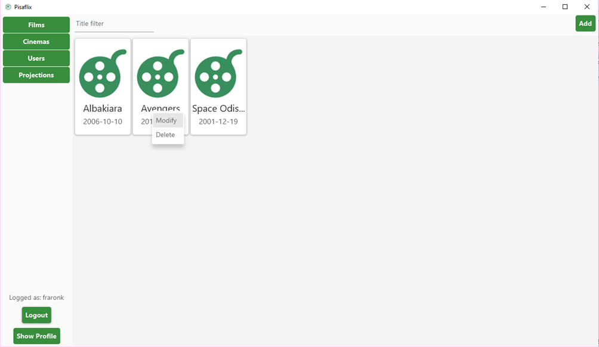

### FILM/CINEMAS Details

After clicking on a film/cinema during browsing, the application will show the film/cinema detail page which contains all the information about it and also all the comments of the users.

In that page a logged user can add the film/cinema to its favourite (1) or comment it (2).



Then the user can also modify/delete their own comments by right clicking on them:

With the right privileges a user can also delete other users’ comments:

### BROWSING USERS and details

Similar to browse films/cinemas a user can also navigate through other users by the apposite button in the top left corner, the page shows all usernames and privileges.

With the right privileges a user can modify others user privileges by right clicking on them ad using the apposite menu (1).



Once the user clicks on a user while browsing it will open its page detail:

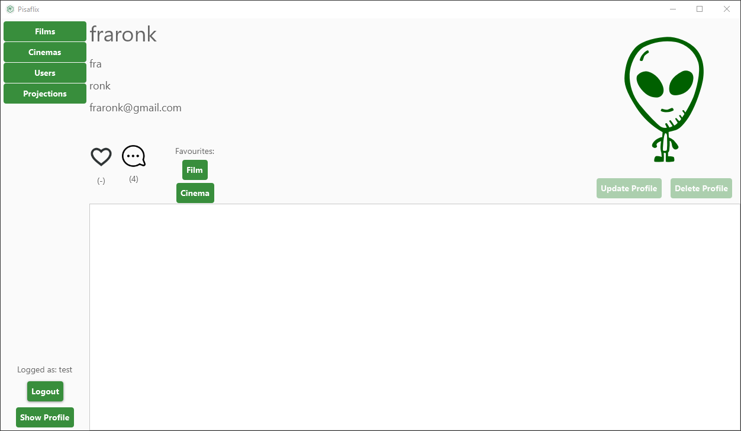

In the detail page is visible how many favourite/comment a user did and a list of his favourite films and cinemas by clicking on the respective buttons.

On his personal page, a user can modify its information or delete its account:



With the right privileges an administrator can have the possibility to delete another user account:

### projection

By clicking the apposite button in top left corner, the application will show the projection page on which the user can see the all the projections available:

On the top of the page there are three filters that users can use to search for the projections:

* By Date
* By Cinema
* By Film

All or no filters can be used simultaneously:

With the right privileges the user can also remove a projection or add a new one, with the apposite buttons that will appear next to the search button:

